Git Hands-On Lab
Aim:
To implement the .gitignore file to ignore unwanted files and folders from being tracked by Git.
Tools Required:
- Git Bash
- GitHub
- Notepad++
- Windows PC
- Existing Git Repository (GitDemo)
Procedure:
- Open the existing Git repository (GitDemo).
- Create a .log file and a log folder.
- Create a .gitignore file.
- Add rules to ignore .log files and the log folder.
- Save the .gitignore file.
- Verify the ignored files using git status.
- Commit and push the .gitignore file to GitHub.
Commands Used:
- cd ~/GitDemo
- touch sample.log
- mkdir log
- touch .gitignore
- notepad .gitignore
- git status
- git add .gitignore
- git commit -m "Added .gitignore"
- git push

Contents of .gitignor

*.log
log/

Fig. 1: Creation of sample.log file and log folder.

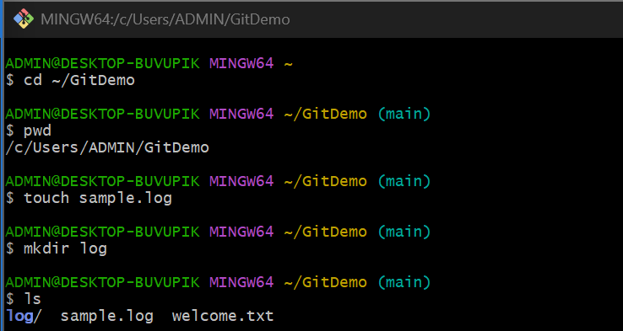

Fig. 2: Output of git status showing only .gitignore as an untracked file.

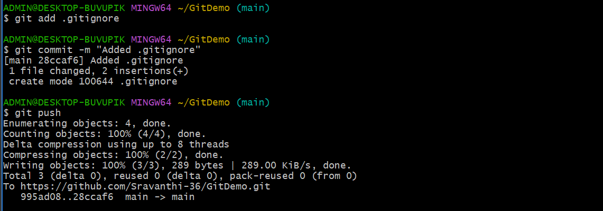

Fig. 3: Notepad++ showing

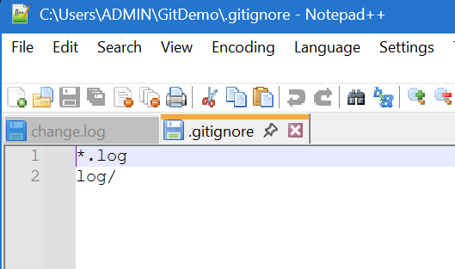

Fig. 4: Successful push to the GitHub repository.

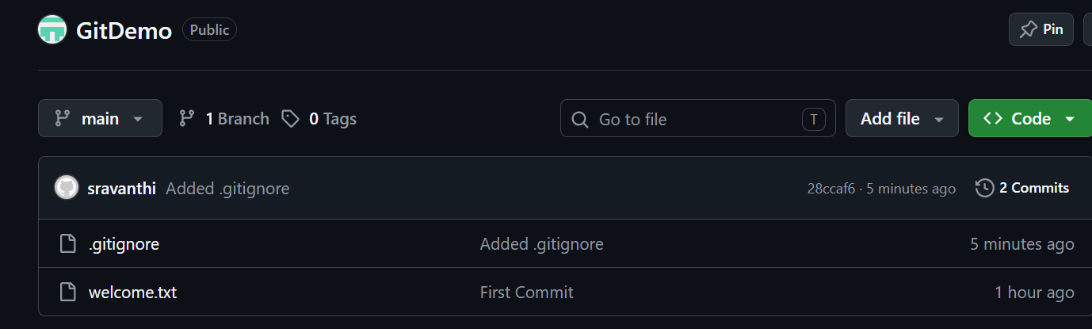

Result:
Successfully implemented the .gitignore file to ignore .log files and the log folder. Verified that ignored files were not tracked by Git and successfully pushed the changes to the remote GitHub repository.

